Software Requirement Specifications Document
V1.0

Patient Study Calendar – Robert H. Lurie Comprehensive Cancer Center

DOCUMENT CHANGE HISTORY
Version Number | Date | Contributor | Description
V1.0 | 8/7/06 | Sean Whitaker | First Draft
V1.1 | 8/22/06 | Sean Whitaker | Revision of First Draft

TABLE OF CONTENTS
1. Background/Summary 2
2. Introduction 3
Document Overview 3
Related documents 4
Application System Diagram 5
Application Core Data 5
Release Overview 6
Definitions 6
3. caBIG requirements 7
Vocabularies and Data Elements 7
Environment 7
4. Application Functional Requirements 8
New user creation and login 9
New User Registration 9
Logging into the System 9
Retrieving Forgotten Password 9
Contacting Administrator 10
5. APPLICATION NON-functional requirements 10
GUI Specifications 11
Security Requirements 11
Audit 11
Database schema 12
Performance criteria 12
6. Requirement Change Management 12
7. GLOSSARY 15

Background/Summary
The business driver behind the caBIG CTMS Study Calendar Module is the creation of an open source, standards-compliant software application that can be used by organizations that manage patients on cancer clinical trials. The caBIG CTMS Study Calendar Module will support the application of a study template to study participants and enable the prospective forecasting of visit information and provide a framework for reviewing historical study calendar events. The caBIG CTMS Study Calendar will support studies that include therapeutic, observational, correlative, ancillary, and biobanking aspects. The standalone Study Calendar module will integrate with the components necessary to create study calendar templates (protocol authoring), be able to instantiate a template for study participant and represent study events for that participant. These study events will be uniquely identified at a study participant and event level, enabling the stable linking to external systems such as patient scheduling systems, laboratory interfaces, adverse event reporting modules, case report forms, and other event-based data that are specified by a study.
The study calendar will serve as an event-centric hub for linking these data, but the study calendar module itself will not model or extend into these domains.
Functionally, the Study Calendar will include features to support patient screening and registration, adaptable schedule definitions and security model implemented using the CSM that is suitable for multi-site protocols, alerts for upcoming events and missed events, ability to track and report on dates of anticipated versus actual events, and complete reporting of patient accrual, missed events, and schedule deviations. The Patient Study Calendar will support the accrual definitions necessary for CCSG reporting.

Introduction

Document Overview
The System Requirements Document (SRS) includes detailed functional requirements for the system on ‘what’ are the behaviors based on specified end-user use cases as well as non-functional requirements such as GUI, quality &performance, usability and system behavior requirements that directly or indirectly impact the system.
The Patient Study Calendar module will have three functional components that reflect the three aspects of the data model: a template view, a prospective view, and a retrospective view.
- The template view of the Patient Study Calendar module is an electronic representation of the eligibility/treatment/monitoring/follow-up lifecycle for a specific study, as typically listed in the study parameters table of the study protocol.
- The prospective view is the result of applying the template view to a specific participant with a start date. The prospective view is an instantiation of the template for a study participant and by combining the start date of that participant with the days specified in the template view, discrete dates for future events can be calculated.
- The third component to the Patient Study Calendar module is the retrospective view. Once the date of an event created by the prospective component has passed, details about that event must be entered to reconcile if it happened, when it happened, and provide a unique, stable identifier for these events that can be used by other modules and systems.
The Study Calendar Module is being developed with significant input from groups that have been identified as Primary Stakeholders in the project. These stakeholders are key contributors in defining system requirements and associated use cases. They include:
- A user group from the Robert H. Lurie Comprehensive Cancer Center of Northwestern University Clinical Research Office. This group meets as needed to provide information and feedback to the development team and is key in the development of use cases.
- A Requirements Group that includes representatives from several cancer center and development team members. This group holds weekly teleconferences and focuses on requirement specifications.
The Study Calendar SIG, which has twice-monthly teleconferences. The focus of calls mirrors the activities underway in the development project, with the discussion of use cases and requirements as key agenda items.

Related documents
Document Name | Version | Location
Vision & Scope doc. | 1.0 | http://gforge.nci.nih.gov/docman/view.php/31/2610/Vision and Scope.doc
Use Case Doc. | 1.0 | http://gforge.nci.nih.gov/plugins/scmcvs/cvsweb.php/studycalendar/Release1/Draft Use Case.doc?cvsroot=studycalendar
Architecture Doc. | 1.0 | http://gforge.nci.nih.gov/plugins/scmcvs/cvsweb.php/studycalendar/Release1/Draft UML Model.EAP?cvsroot=studycalendar

Application System Diagram

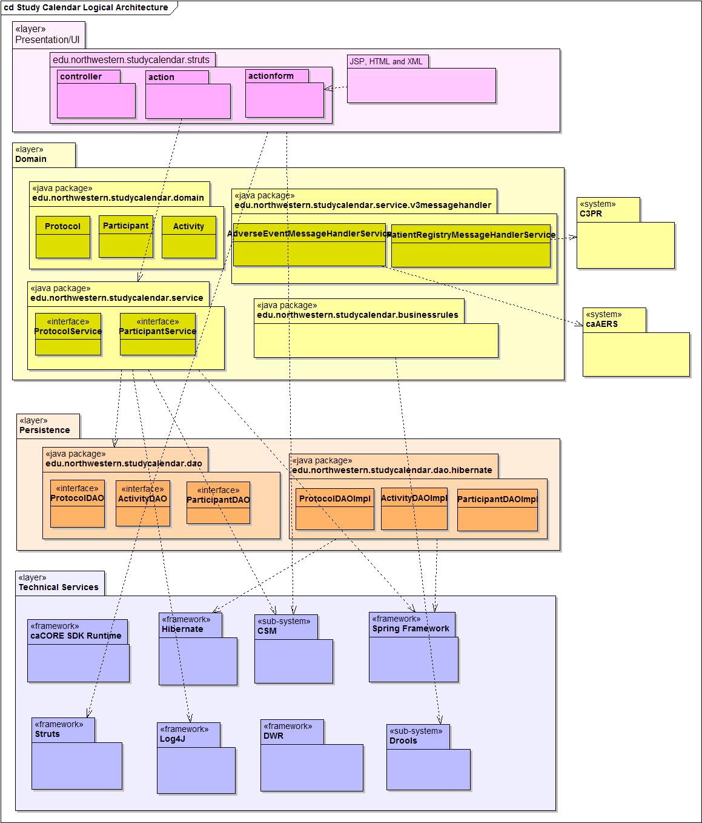

Application Core Data
To be determined in Release 2.

Release Overview

Release | Date Released | Version comments
Prelude | 6/26/06 | Planning documentation and development environment
Release 1 | 8/7/06 | First software release and documentation
Release 2 | 9/18/06 | Software and documentation refinements
Release 3 | 10/30/06 | Software and documentation refinements
Release 4 | 12/04/06 | Final software release

Definitions
Developers and Adopters are expected to clearly understand on the definitions and agree upon the ranking of the definitions used with any given requirement.
MUST - This word means that the definition is an absolute requirement of the specification.
MUST NOT - This phrase means that the definition is an absolute prohibition of the specification.
WILL - This word means that the definition is an absolute future requirement of the specification.
WILL NOT - This phrase mean that the definition is an absolute future prohibition of the specification.
SHOULD - This word means that there may exist valid reasons in particular circumstances to ignore a particular item, but the full implications must be understood and carefully weighed before choosing a different course.
SHOULD NOT - This phrase means that there may exist valid reasons in particular circumstances when the particular behavior is acceptable or even useful, but the full implications should be understood and the case carefully weighed before implementing any behavior described with this label.
MAY - This word means that a requirement is truly optional. The developer may choose to include the item based on the needs of their design.

caBIG requirements

Vocabularies and Data Elements

One of the main goals of caBIG is to ensure that all applications use the same vocabulary and data elements for similar concepts across the grid. This will eliminate any inconsistency in data descriptors (metadata) and make it possible to pass semantically equivalent data with confidence across various applications within the grid
R# | Req. Name | Requirement details
NFR026 | Ensure caDSR compliance | Patient Study Calendar must use Enterprise Vocabulary Services (EVS) and Cancer Data Standards Repository (caDSR) for each and every data element and concept which will be exposed to the grid.

Environment
All caBIG projects must be platform and database-independent applications. In the case of Patient Study Calendar, it means it should be possible to run it on any operating system, should support any database and should work on any web browser.
However, considering the large number of combinations of test scenarios, Patient Study Calendar must at least be certified on the following scenarios:
Operating system | Mac OS X
Operating system | Windows XP, 2003 Server
Operating system | Linux
Database | Oracle 9i, 10g
Database | PostGRES 8
Browser | Firefox 1.5
Browser | Internet Explorer 6
Java | 1.5

Roles
System Administrator | - Is a "super-user" who manages the application  - Approves and manages user registration process  - Grants users to a role within the application
Study Administrator | - Reviews completed Study Calendar templates to determine if they are complete and correct  - Determines which studies will be editable/viewable for each Clinical Research Coordinator and viewable for each Research Associate
Clinical Research Coordinator | - Creates new Study Calendars  - Assigns Participants to Calendars for which approval has been granted  - Views Calendars for which approval has been granted
Research Associate | - Views Calendars for which approval has been granted

Application Functional Requirements
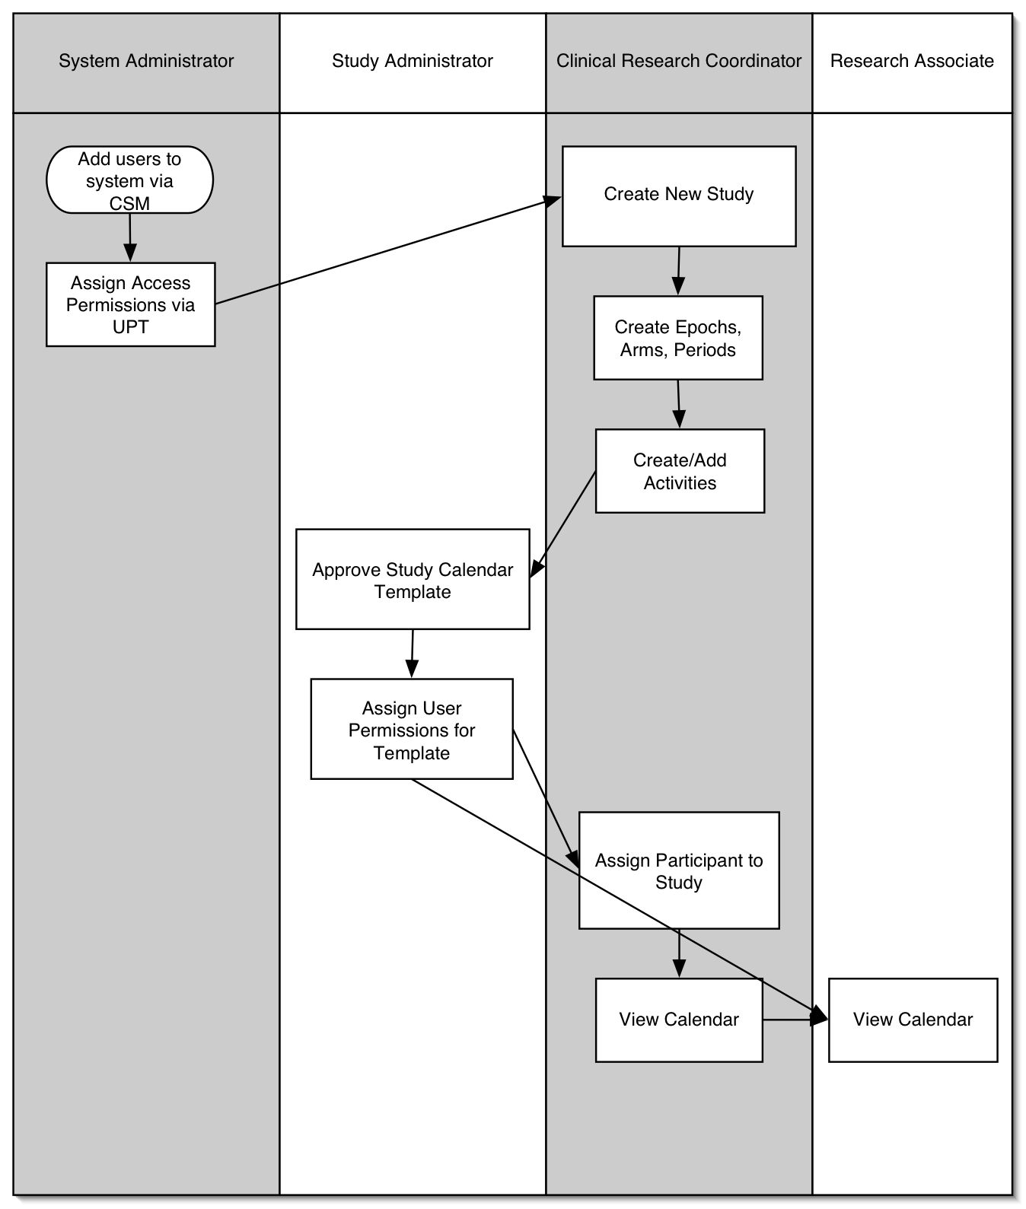

New user creation and login
This section describes the requirements for the following four functionalities:
- Registration of new users
- Logging into the system
- Retrieving forgotten password
- Reporting a problem without logging into the system

New User Registration
The new user registration process will rely on the User Provisioning Tool of the NCICB Common Security Module.

The following requirements describe this process of User Registration

R # | Req. Name | Requirement details
FR001 | User Registration | User is registered and granted appropriate rights by the System Administrator through the UPT.

Logging into the System
Once a User’s access has been setup in the UPT, the user can login to the system using their username and password.

The following requirements describe this process of Logging into the System:

R# | Req. Name | Requirement details
FR002 | Login and Authentication | Login uses CSM, access rights determined by UPT.

Forgotten Password
If a user forgets his or her password, he or she will need to contact the System Administrator to reset the password.

The following requirements describe this process of Retrieving Forgotten Password

R# | Req. Name | Requirement details
FR003 | Forgotten Password | If a user forgets his or her password, he or she will be able to contact the System Administrator to reset the password.

Contacting Administrator
A user should be able to follow a link to send an email to an administrator to report problems with any page.

The following requirements describe this process

R # | Req. Name | Requirement details
FR004 | Contact Administrator Link | If problems with a page arise, the user will be able to contact the System Administrator.

View Current Study Templates
After successfully supplying login credentials, a user will be shown a page that lists all the Study templates that he or she is authorized to view.

The following requirements describe this process

R # | Req. Name | Requirement details
FR005 | View Current Templates | After login, system checks user’s access to templates and displays those for which access has been granted.

Assign User Permission to use SCM via UPT
The System Administrator, after creating a user’s account, will be able to login to the UPT and set the user’s access to SCM resources.

The following requirements describe this process

R # | Req. Name | Requirement details
FR006 | Assign User Permissions via UPT | UPT configured to allow System Administrator to set a user’s access to SCM resources according to the user’s role.

Create New Study
A Clinical Research Coordinator, after successful logon, will be presented with a link to create a new Study within the SCM.

The following requirements describe this process

R # | Req. Name | Requirement details
FR007 | Create new Study | System determines if user is permitted to create new Studies. If so, link is presented. Link will take user to a study creation page, beginning with entering a name for the study.

Add Arms to the Study
The SCM supports representing studies that have multiple arms. During study creation, the user will be able to indicate that a study has multiple arms and then enter the number of arms and a name for each arm.

The following requirements describe this process

R # | Req. Name | Requirement details
FR008 | Add Arms to Study | During study creation, user is given the option to add arms to the study. If this option is selected, the user will be prompted to choose the number of arms and create a name for each arm.

Add Epochs to Study
User will be able to define Epochs during study creation.

The following requirements describe this process

R # | Req. Name | Requirement details
FR009 | Add Epochs to Study | During study creation, user is prompted to add epochs to the study. The user will determine the name, order, and duration of each epoch.

Add Periods to Arms
The SCM supports the notion of repeating periods on the arms of a study. During study creation, the user will be able to add any number of periods to each arm.

The following requirements describe this process

R # | Req. Name | Requirement details
FR010 | Add Periods to Arms | After the user has created arms, the user will be able to select an arm to add periods to it. Periods will be added one at a time. Each period will have a name, a duration, an indicator of when on the arm it will start, and a number of repetitions.

Add Activities to Periods
During study creation and after periods have been created, the user will add activities to the template. These activities will be defined within the context of the period to which they belong.

The following requirements describe this process

R # | Req. Name | Requirement details
FR011 | Add Activities to Periods | After periods have been created, the application will allow the user to add activities to the template. The interface should allow the user to narrow the choice of available activities by first selecting an “activity type.”

Create new Activities
If an activity to be placed onto the calendar does not exist in the current list, the user may create a new activity.

The following requirements describe this process

R # | Req. Name | Requirement details
FR012 | Create New Activities | During the process of adding activities to periods, if a user finds that an activity is missing from the list, he or she will follow a link to a “Create Activity” page. This page will allow for creation of an activity with an Activity Name and Activity Type.

Approve Study Calendar Template
The Study Administrator will logon to the application, review any completed templates, and mark the accepted templates as complete.

The following requirements describe this process

R # | Req. Name | Requirement details
FR013 | Approve Study Calendar Template | After successful logon, Study Administrator will be presented a link to review templates that have been completed by CRCs but not yet approved. After reviewing the template, the SA will be able to mark the template as being complete and accurate.

Assign User Permissions to Completed Study Template
A Study Administrator will assign user permissions to a completed, approved study template to determine which Clinical Research Coordinators will be able to assign participants and which CRCs and Research Associates will be able to view a participant’s calendar.

The following requirements describe this process

R # | Req. Name | Requirement details
FR014 | Assign Permissions to Template | After marking a template as being complete and accurate, Study Administrator is able to determine which CRCs and RAs are able to use it. Study Admin will be able to logon to the system at any time and add or subtract users from templates under his or her control.

Assign Participant to Study
A Clinical Research Coordinator will be able to assign a participant to a study template that has been approved by a Study Administrator.

The following requirements describe this process

R # | Req. Name | Requirement details
FR015 | Assign Participant to Study | CRC logs in to system and is able to see the completed templates that have been approved and assigned by the Study Admin. The CRC is then able to assign participants to the study calendar template.

View Calendar
After a Clinical Research Coordinator has assigned participants to a study, CRCs and Research Associates are able to view the participant calendars for approved studies.

The following requirements describe this process

R # | Req. Name | Requirement details
FR016 | View Calendar | CRC or RA logs on to system and is able to see calendars for the participants on studies to which access been granted by Study Admin.

APPLICATION NON-functional requirements

GUI Specifications
The National Cancer Institute Center for Bioinformatics NCICB has published User Interface (UI) guidelines to promote visual and functional consistency across all applications comprising the NCI e-community so that the user can have a consistent foundation of navigation, behavior, and appearance. They have also published a UI library intended to be used in conjunction with the UI guidelines.
The following is a list GUI requirements to include the design, layout and usability.
R# | Req. Name | Requirement details
NFR001 | UI Setup | GUI specifications will be compliant w/ NCICB UI guidelines

Security Requirements
The following table contains the different kinds of user groups:
System Administrator | - Is a "super-user" who manages the application  - Approves and manages user registration process  - Grants users to a role within the application
Study Administrator | - Reviews completed Study Calendar templates to determine if they are complete and correct  - Determines which studies will be editable/viewable for each Clinical Research Coordinator and viewable for each Research Associate
Clinical Research Coordinator | - Creates new Study Calendars  - Assigns Participants to Calendars for which approval has been granted  - Views Calendars for which approval has been granted
Research Associate | - Views Calendars for which approval has been granted

The following is a list of security requirements:
R# | Req. Name | Requirement details
NFR002 | Role-based Security Set-up | System Administrator will assign user to role (see table above) using UPT
NFR003 | Enforcement of Role-based Security | Role-based security must be enforced throughout the SCM

Audit
The system must be possible to audit each and every user action that results in database access (read or write). Examples include: add/edit administrative or patient treatment data, user login, query, distribution, and so forth.
The audit information must contain the following information:
- User who performed the action
- IP address of the computer from which the action is performed
- Timestamp of action
- Object and data element (i.e. table name and column name)
- Previous value and current value of the data element

R# | Req. Name | Requirement details
NFR004 | Audit user actions | SCM will capture required audit information (see list above)

Database schema
Database schema will be recreated using an Ant task and Bering. SCM will be designed to be as database-independent as possible and will be tested with both Oracle and PostgreSQL.
The following are the requirements for the database schema:
R# | Req. Name | Requirement details
NFR005 | Reproduce Database Schema | Using Ant and Bering w/ a properly configured database, any site will be able to recreate the database schema automatically. Details will be provided in the Installation Guide. <insert link when available>
NFR006 | Database Compatibility | SCM will be tested to function correctly with both Oracle and PostgreSQL.

Performance criteria
The below table will contain the performance criteria based on the application functions and result output. It includes internal and external dependencies that may impact the application performance.
R# | Req. Name | Requirement details
NFR007 | Performance Data | The SCM relies on relatively small datasets. We currently do not foresee a scenario in which any transaction requires more than 5-10 seconds to complete. We will update this estimate as the module matures.

Availability
The following is a list of Availability requirements
R# | Req. Name | Requirement details
NFR010 | Availability | The SCM will be able to run 24/7 except for scheduled software updates.

Completeness
The following is a list of Completeness requirements
R# | Req. Name | Requirement details
NFR011 | Completeness | The SCM will be able to ensure that the primary pieces of the of template exist and will provide the Study Administrator with the opportunity for manual review.

Correctness
The following is a list of Correctness requirements
R# | Req. Name | Requirement details
NFR012 | Correctness | The SCM will be able to accurately represent all data entered into the system as it was entered and will provide the Study Administrator with the opportunity for manual review.

Cost of ownership
The following is a list of Cost of Ownership requirements
R# | Req. Name | Requirement details
NFR013 | Cost of ownership | All required components to run SCM and the SCM itself will be open source and freely available. The only Cost of Ownership will be the time required to install and maintain the SCM.

Compatibility
The following is a list of Compatibility requirements
R# | Req. Name | Requirement details
NFR014 | Compatibility | The SCM will be BRIDG harmonized as much as possible.

Environment
The following is a list of Environment requirements
R# | Req. Name | Requirement details
NFR015 | Environment | The SCM will run on systems as detailed in Section 3 above.

extensibility
The following is a list of Extensibility requirements
R# | Req. Name | Requirement details
NFR016 | Extensibility | The SCM is being developed in an iterative, extensible way. Each release builds upon and extends the functionality of the last. With the source code and UML models being freely available, any Java developer should be able to extend the SCM in any way he or she requires.

installation complexity
The following is a list of Installation Complexity requirements
R# | Req. Name | Requirement details
NFR017 | Open Source Installation | The SCM will be installable using only open-source components.
NFR018 | Complexity of Install | The SCM will provide an installation package and manual, but knowledge of deploying Java-based web apps will be assumed.

Portability
The following is a list of Portability requirements
R# | Req. Name | Requirement details
NFR019 | Portability | The SCM is a stand-alone module and can be installed in any environment.

regulatory
The following is a list of Regulatory requirements
R# | Req. Name | Requirement details
NFR020 | Regulatory | Transactional auditing will assist organizations in compliance w/ various regulations.

reusability
The following is a list of Reusability requirements
R# | Req. Name | Requirement details
NFR021 | Reusability | The SCM should be able to function as a patient study calendar for any cancer clinical research institution.

Scalability
The following is a list of Scalability requirements
R# | Req. Name | Requirement details
NFR022 | Scalability | The SCM will be able to accommodate the number of templates and protocols of any cancer center.

Time to market
The following is a list of Time to Market requirements
R# | Req. Name | Requirement details
NFR023 | Time to Market | The development cycle of the SCM ends December 4, 2006.

Training complexity
The following is a list of Training Complexity requirements
R# | Req. Name | Requirement details
NFR024 | Training Complexity | A Clinical Research Coordinator should find the system intuitive and easy to learn.

usability
The following is a list of Scalability requirements
R# | Req. Name | Requirement details
NFR025 | Usability | Must be user-friendly and intuitive for clinical trial professionals to use.

Requirement Change Management

All changes in requirements are managed and recorded in our ticket tracking system. This ticket system allows us to link tickets to our wiki and version control system. All developers, testers, and QA personnel have the ability to create and edit tickets, others are granted this right by request.
In addition to the required fields of Date, Submitted By, Change Type, Change ID, Change Details, and Status, our change management system also allows us to track Priority, Completion Time Estimate, Assigned To, Associated Component, Associated Release, and Change History. Project managers receive an automated notification anytime a ticket is added or modified. We review open tickets each week during our development meetings and reach consensus about who will complete each ticket. This community review process ensures that each member of our development team has work to complete that he or she understands, and that progress is being made on each ticket.
Sample Ticket:
Field | Sample Data
Date | 6/26/06
Submitted By | mmhohman
Change type | enhancement
Change ID | Ticket #19
Change Details | Create an activity, providing a name, activity type, and text description, shared across all studies
Status | Closed
Priority | Major
Completion Time Estimate | 20 hours
Assigned To | Jaron
Associated Component | Software
Associated Release | Release 1
Change History | Chronographic list of changes to ticket

Change Workflow:

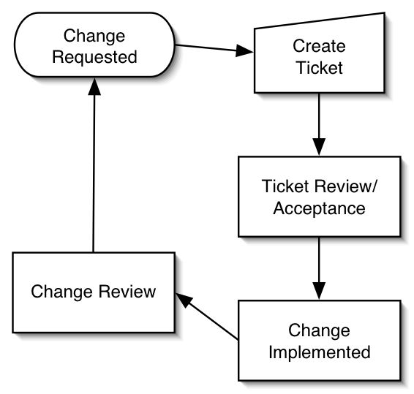

GLOSSARY
Screening: The process of evaluating a subject for eligibility and potential participation in a clinical trial. The formal screening process begins at the time that consent is obtained and prior to the initiation and performance of any procedures identified as being research-related. The screening period ends when a subject is registered to the study or determined to be ineligible.

Note: Identification of patients as potential subjects (pre-screening) can occur prior to consent as long as no procedures or assessments determined by the protocol to be research-related are performed.

Registration: This is a formal method of entering a patient onto a given trial. The timing and method of registering a patient onto a study is typically described in the protocol or per the corresponding organizational SOPs.

Note: the decision was made not to use the term enrollment, due to inconsistencies in this definition at various sites. Some sites, for example, define enrollment as occurring when a consent form is signed, while others do not define it as occurring until registration.

Arm: A branch of the protocol design to which study participants are assigned a specific treatment schedule as defined in the protocol. Every protocol has at least one arm. When there is more than one arm, the subject will receive an ARM ASSIGNMENT upon registration.

Randomization: The process of assigning trial subjects to treatment or control groups (a study Arm) using an element of chance to determine the assignments in order to reduce the bias (ICH 1.48). This can occur at the time of subject registration to a trial or at protocol defined time points after initial registration (e.g., when a subject finishes one treatment regimen and will be moving on to 1 of 2 new regimens).

Active Monitoring: The process of monitoring that tests, procedures and other evaluations associated with an arm regimen are appropriately conducted as defined by the protocol. This period begins with subject registration and ends when all study activities (tests, procedures, face-to-face evaluations, etc.) as defined by the protocol schedule have been completed. Active monitoring may involve active assessment of the participant with or without continuance of the research intervention (therapeutic or other) - the constant is that the participant is still managed, i.e., is having tests, procedures and face-to-face evaluations, according to a pre-defined, protocol-specific schedule.

Long Term Follow Up: The period that begins when the subject has completed active monitoring until such time that no further information is being collected regarding the subject. Typically, subjects in long-term follow up are being monitored for events – death, possibly disease progression, etc. but there are no scheduled test/procedures or evaluations.

